Left Recursion and Left Factoring

# 

# Submitted to:

* Dr. Talha Waheed

# Submitted by:

* Komal Shehzadi (2016-CS-178)

# Department of Computer Science and Engineering

# UET Lahore



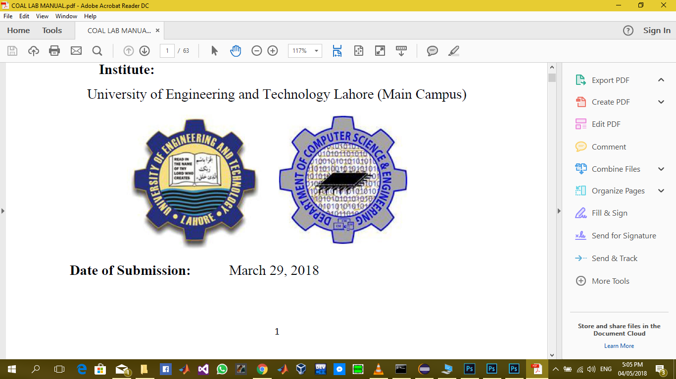

# Removal of Left Recursion and Left Factoring



 

